Capstone Project Plano by airon

User Roles
- Each Roles have Dashboards (Admin / Collector / Unit Tenant | Owner
Admin
- Manage Billing Collector and Resident Account (Add/ Update/ Edit Accounts).
- Assigns users to units
- Manage Units( Update Units if Occupied/ Vacant…etc)
- Checks the Statement of Account(SOA) per units( comes from the collector)
- Sends the SOA to the unit owner forward them to email or or Tenant Dashboard
- Checks the Payment Proof from tenants and Verify payment proof
- Generate and Export monthly summaries and reports
- View dashboards, collection summaries, overdue accounts, audit logs
- Configure association dues and notifications, due dates
- View Audit Logs

Collector
- Upload or import current billing month excel file received by maintenance
- Validate uploaded billing data
- Create the current billing period
- Generate SOA once the current billing is uploaded into the system
- Manages the configuration association dues, due dates
- Manage SOA and edit template
- Send the current SOA to admin landing page
- View Units
- View Payment Records that is verified by admin
- Update Tenants payment record
Billing landing page example
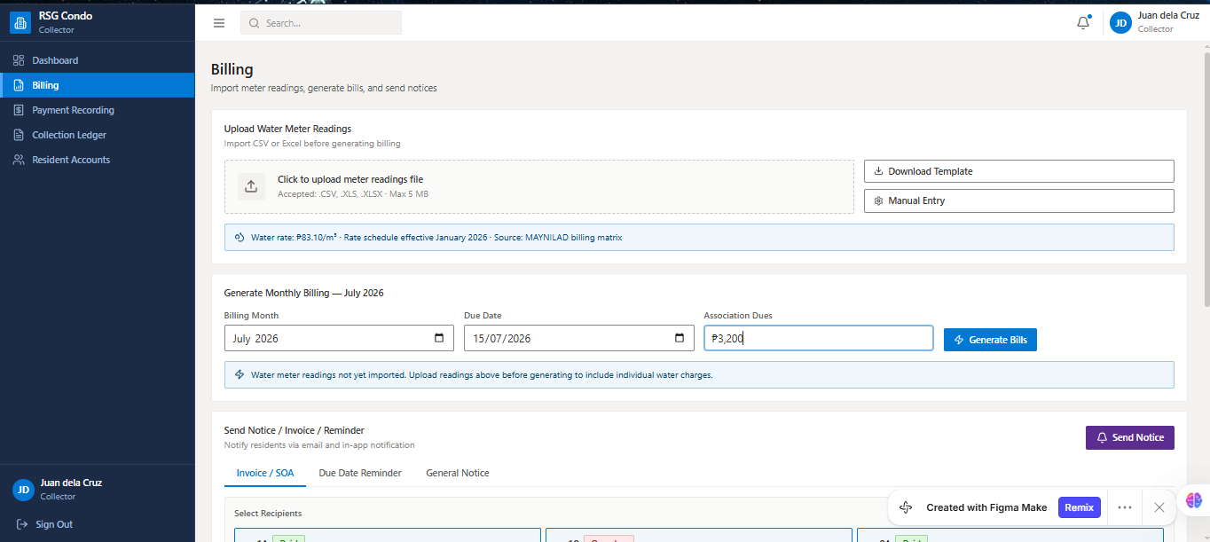

Tenants / Owner
- View Current water bill, association dues, total amount, due date
- View and Download SOA(Statement of Account)
- Notifications in Landing Page (can see if Received email)
- Submit Payment Proof using OCR if have receipt(OCR auto matically read the receipt and will generate the data
- View Payment History ( Pending/Paid/Partial/Overdue/Rejected)
- View Water Billing and also predictive analytics of water billling, present + future bill
- See prescriptive analytics
- (Consider:a owner can have multiple units)
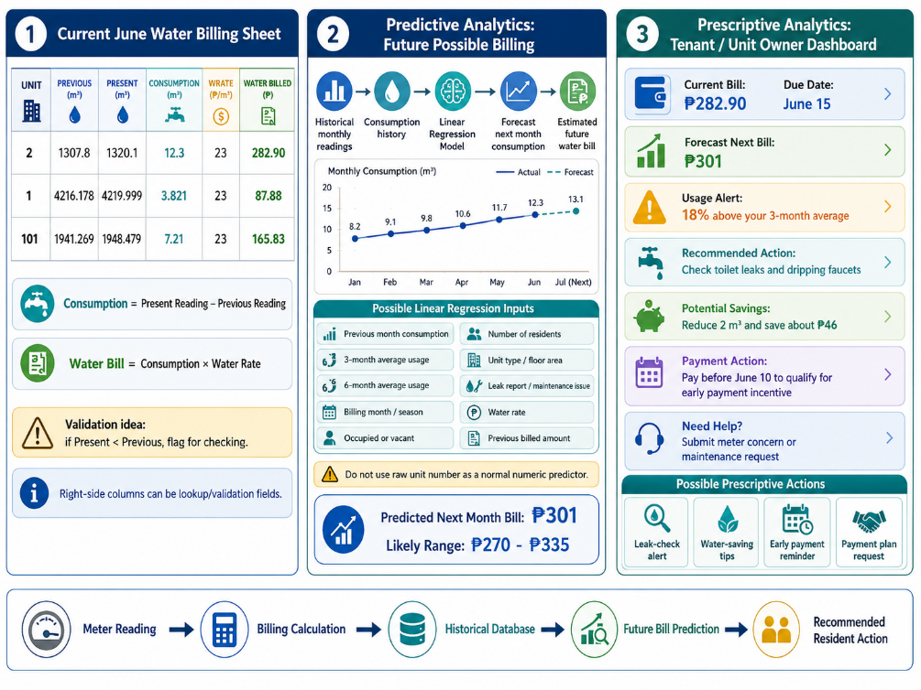
- Example:

Example of Predictive and Prescriptive analytics in Owner / Tenants
CURRENT BILL
June Water Charge: ₱282.90
Due Date: June 15
NEXT MONTH FORECAST
Estimated July Bill: ₱301
Likely Range: ₱270–₱335
USAGE ALERT
June consumption is 18% above your 3-month average.
RECOMMENDED ACTION
Check toilets and faucets for leaks.
Potential savings: up to ₱48 next month.
PAYMENT ACTION
Pay before June 10 to qualify for an early-payment incentive.

Condition detected | Prescriptive recommendation
Forecast is 15%+ higher than the unit’s three-month average | Check toilet flushes, faucets, showerheads, and visible leaks
Unit is marked vacant but water consumption is above the threshold | Request physical inspection for leaks, unauthorized use, or incorrect occupancy status
Three consecutive months show rising consumption | Notify resident and recommend water-saving actions
Predicted bill exceeds owner’s selected budget | Show how many cubic meters must be reduced to meet the budget
Meter reading is unusually high or lower than the previous reading | Ask collector to recheck the meter reading and upload a meter photo
Due date is within five days and there is an unpaid balance | Send payment reminder to the assigned payer
Forecast is near the unit’s usual high-consumption level | Encourage early monitoring before the next meter reading

//I
Interview with admin notes: (IGNORE THIS)
- -The admin is called consultant
- Admin only checks the payment (if owner have proof of payment)
- Admin says to add some maintenance concern owner reporting features
- Tenant is not owner, tenant pays(rent, water used, electricity(paid directly to meralco))
- Association dues is responsibility of the unt owner( some cases rental agreement make them pay the association dues indirectly)
- In the condo they handle water billing and association fees
- Tenant Payer take screenshot of payment and send it to admin and will send it to collector to validate and record the payment “admin says: The normal process should be direct payment to the collector or accounting. However, I require the payment proof to pass through me first so that I can monitor it. If someone pays directly and a payment is missed in the billing record, I may not know whether the person has already paid. With the screenshot sent to me, I can also verify the payment and forward it to the collector.”
- Association dues are fixed for specific unit, water charge changes.
- Collector

System Requirements Recommendation
- Billing records must include association dues, water charges, billing period, due date, amount due, amount paid, payment date, payment status, and remaining balance.
- Association dues are fixed by unit size. Water charges change according to meter readings.
- The system should support role-based dashboards for at least the administrator/consultant and collector.
- The administrator/consultant needs to monitor and validate payment proof, especially payments not yet reflected in the collector's record.
- The collector needs functions for billing preparation and payment recording.
- The dashboard should show total units, total collected, pending or unpaid units, and detailed per-unit information.
- Unit status should support occupied and vacant labels with manual updates.
- Monthly summaries should show billed amount, collection amount, outstanding balances, and optionally collection efficiency.
- The system should distinguish billed amounts from cash received in a month because late payments and annual advance payments affect collections.
- Annual advance payment with one free month is a business rule that may need to be supported.
- A 2% late-payment penalty was mentioned but must be verified before implementation.
- Historical monthly billing data per unit is needed for future possible billing prediction.
- Electricity billing is not in the initial scope. Maintenance reporting and expense tracking are possible future modules but were not confirmed as core scope.
- Unit owners should have a portal that limits access to their own bill and payment information.
- Current Excel data and the actual collector workflow must be reviewed with Sir JB/Jimmy before finalizing the requirements.

- Define the PROBLEM
-RSG Condominium currently relies on manual billing files, manual Statement of Account preparation, and payment-proof checking through screenshots or messages. This makes it difficult to monitor unit billing, payment status, overdue balances, and monthly collections accurately. Unit owners and tenants may not have immediate access to their current SOA, payment history, future possible water bill, or billing notifications. The administration also lacks a centralized system for monitoring financial records, verified payments, and audit history.
THE SYSTEM SOLVES:
- Manual monthly billing processing
- Delayed or unorganized SOA distribution
- Manual payment-proof verification
- Difficulty tracking paid, pending, rejected, and overdue bills
- Difficulty producing monthly financial summaries
- Lack of owner/tenant visibility over current and future water billing
- No centralized audit trail

-Users: Who will use it?
-Collector, Admin, Tenants/Owner
Roles: What can each user access or do?
User | Main purpose in the system
Admin | Monitors operations, manages accounts and units, verifies payment proofs, sends SOAs, views reports, and configures system settings.
Collector | Uploads the monthly billing file, generates SOAs, manages SOA templates, views units, and updates verified payment records.
Owner/Tenant | Views assigned unit billing, downloads SOA, receives notifications, submits payment proof, views payment history, and sees water-billing forecasts and recommendations.

Main workflows: What actions happen from start to finish?
• Login and Role Access
- User logs in.
- System validates credentials.
- System checks account status and role.
- User is redirected to the correct dashboard.
• Account and Unit Management
- Admin creates or updates user accounts.
- Admin assigns owners or tenants to units.
- Admin marks units as occupied or vacant.
- System records the action in the audit log.
• Monthly Billing and SOA Generation
- Collector uploads monthly billing Excel file.
- System validates meter readings and unit data.
- System calculates water charges and association dues.
- System creates billing records.
- System generates SOA per unit.
- Admin reviews and sends SOAs.
• Payment Proof Verification
- Owner or tenant uploads receipt screenshot.
- OCR extracts possible receipt details.
- Admin checks the proof.
- Collector records the payment after verification.
- System updates payment status and remaining balance.
- System notifies the resident.
• Water Forecast and Prescriptive Analytics
- System uses historical meter readings and billing records.
- System predicts possible next-month water consumption and charge.
- System detects unusual consumption or high forecast.
- System displays recommendations or alerts.
Inputs: What data enters the system?
User/System Source | Input Data
Admin | User account details, role assignment, unit status, owner/tenant assignment, association dues rate, notification settings, SOA delivery action, payment-proof verification result
Collector | Monthly billing Excel file, meter readings, billing period, water rate, SOA template changes, verified payment record updates
Owner/Tenant | Payment proof image, receipt reference number if manually entered, payment date, payment method
System | OCR-extracted amount, OCR reference number, OCR payment date, calculated charges, remaining balance, billing status, forecast result, notification records
Historical Records | Previous meter readings, prior water charges, payment history, monthly billing history
Outputs: What reports, receipts, dashboards, notifications, or results are produced?
Output | Who receives it
Generated SOA per unit | Owner/Tenant, Admin, Collector
Current bill and due date | Owner/Tenant
Payment status: Pending, Paid, Partial, Overdue, Rejected | Owner/Tenant, Admin, Collector
OCR-extracted receipt information | Admin and Collector
Payment confirmation or rejection notice | Owner/Tenant
Monthly billing summary | Admin and Collector
Collection summary | Admin
Outstanding and overdue accounts report | Admin
Unit billing history | Owner/Tenant, Admin, Collector
Water-billing forecast | Owner/Tenant, Admin
Prescriptive recommendation | Owner/Tenant
Audit log | Admin
Exported report such as PDF or Excel | Admin
Rules: What should the system allow or prevent?
Access-control rules
- A user can only access the dashboard allowed by their role.
- An Owner/Tenant can only see units assigned to their account.
- An Owner may see multiple units assigned to them.
- A Tenant cannot see another tenant’s billing, SOA, or payment history.
- A Tenant cannot see a unit owner’s private data unless assigned.
- A Collector cannot manage Admin accounts.
- Only Admin can manage accounts, unit assignments, dues settings, notifications, and audit logs.
Billing rules
- A billing record must belong to one unit and one billing period.
- A unit should not have duplicate billing records for the same billing period.
- Current meter reading cannot be lower than previous meter reading unless flagged for correction.
- Water consumption must be calculated from current reading minus previous reading.
- SOA can only be generated after billing data is validated.
- A generated SOA must show the correct water charge, association dues, total amount due, due date, and payment status.
- A billing status can be Pending, Partial, Paid, Overdue, or Rejected.
Payment rules
- OCR does not automatically confirm a payment.
- OCR only extracts possible receipt details for review.
- Admin must verify payment proof before the collector records the payment.
- A rejected proof must include a reason or status.
- A payment cannot exceed the remaining balance unless advance-payment rules are confirmed.
- A payment reference number should not be recorded twice.
- Payment history must remain visible after payment is marked Paid.
Forecast rules
- Forecasting should only run when enough historical meter-reading records exist.
- The forecast should be labeled as an estimate, not a guaranteed bill.
- Prescriptive advice should be based on clear rules, such as unusual usage or a predicted increase.
- A forecast should not replace the actual monthly billing amount.

Bounderies/ Scope or Delimitation:
Excluded:
- Electricity billing
- Rent collection
- Full accounting system
- Online payment gateway
- Automatic bank validation
- Maintenance complaint management
- Automatic penalty computation, unless RSG confirms the exact rule
- Payment delay prediction

Next is setup the Database/backend, make mvp

Design the system before coding
Create these documents or diagrams:
- Use Case Diagram
Shows users and what each role can do.
- Workflow / Flowchart
Shows the steps for major processes.
Example:
User logs in
↓
System verifies credentials
↓
System checks role
↓
User is redirected to allowed dashboard
- ERD or Database Diagram
Shows tables and relationships.
- Wireframes
Rough page layouts before building the frontend.
- API Plan
Lists what the frontend needs from the backend.

